OCEAN WISE

YOUTHTOSEA HANDBOOK
SEEK • SUPPORT • SHARE

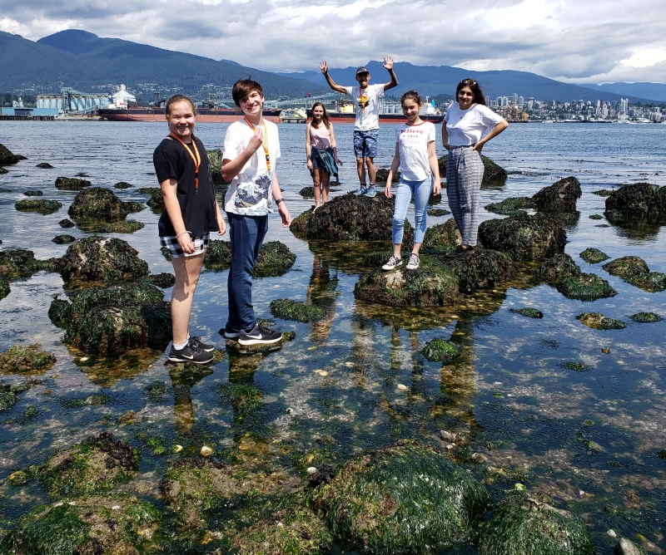

Overview and Goals:
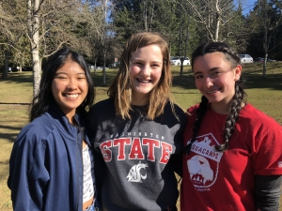
The YouthToSea program was created in 2019 by a small group of passionate youth with a shared interest in ocean conservation. YouthToSea aims to unite youth throughout British Columbia with a common goal: to protect and conserve our oceans. The Council will work towards this goal by developing a vibrant network of youth who will protect our shared oceans by engaging their communities through a variety of ocean projects. Our goal is to create a space where youth can connect and support each other as they take action in their own communities to drive ocean conservation efforts.

YouthToSea members will develop projects to be part of a youth-driven effort to inspire and engage the public in ocean conservation efforts, promoting positive environmental change. YouthToSea is designed to give a voice to youth in discussions about ocean conservation and sustainability, while providing youth with the fundamental resources and tools for effective leadership, advocacy, networking and outreach to promote change. Our members will shape the development and direction of the council and develop their own ideas as well as be part of a larger group of environmental leaders.

Under the direction of Ocean Wise, the YouthToSea Council can provide youth with access to resources and support from professional ocean researchers, conservationists, and educators.

OBJECTIVES:
Our objectives are based on three pillars: Seek, Support, Share. We will empower youth across the province by seeking members with a passion for ocean conservation, supporting them in turning their ideas into action, and sharing their projects to inspire others.
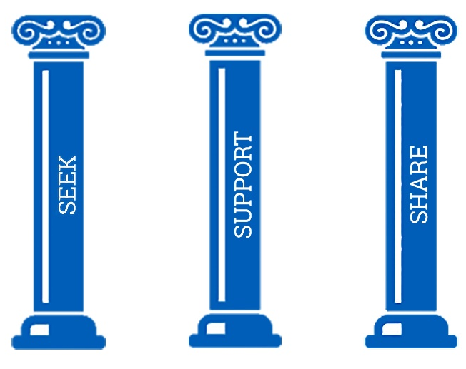
- SEEK: We seek to find youth with passionate ideas to promote Ocean Health and Conservation
- SUPPORT: We support and nurture these ideas to run them into action within the community
- SHARE: We share these ocean projects designed by youth on various media platforms to inspire others to join the cause

ORGANIZATIONAL STRUCTURE
The YouthToSea program consists of an executive council and general program members.

The YouthToSea Council is responsible for advising and supporting the program members. Executives will steer the council by developing events and outreach opportunities, communicating through updates with our members and partners, and supporting all YouthTo Sea members with their projects.

Executive members will be responsible for the following duties:
- Council Development
- Event and Outreach Planning
- Marketing
- Communications
- Content Creation
- Member Outreach
- Member Support and Mentorship

All YouthToSea Executive Council members will be required to be working towards their Duke of Edinburgh International Award, which will be sponsored and supported by Ocean Wise.

The YouthToSea Council is being guided by three professional advisors:
Hailey Renaud, Children and Youth Programs Manager – Ocean Wise
Frankie Marquez, Ocean Bridge Cohort 2019
Michelle Bienkowski, Youth Coordinator – Ocean Wise

MEMBER RESPONSIBILITES
YouthToSea members should expect to develop their own ocean conservation ideas and turn them into action in their community. The list of ideas and events is freeform; wherever your passion lies, YouthToSea will support you in bringing your ideas to life. We expect YouthToSea members to plan and carry out a project for Oceans Week 2020 but will support all projects regardless of timeline including long-term initiatives and single day events. We also encourage youth to participate in outreach opportunities throughout the year to promote ocean conservation in their communities.

YouthToSea members will be responsible for:
- Working individually or collectively to develop and deliver an ocean-themed project or event for World Oceans Day, June 2020
- Being part of monthly group calls to discuss project development and outreach opportunities
- 30 hours of ocean service and outreach throughout the year (leading clean-ups, presentations, documentary screenings)

Members will have access to:
- Workshops at the Vancouver Aquarium (also available online) throughout the 2019-2020 school year to help build their projects
- Professional and student advisors to assist with project development
- A calendar of events to participate/volunteer at
- An online community of youth for support
- Monthly update with summit, conference, and competition opportunities

Following completion of the program participants will receive an official YouthToSea program certificate and community service hours sheet for their resume.

YOUTH DEVELOPMENT
YouthToSea will also provide a variety of resources and workshop opportunities to our youth to help them build employable skills. Workshops may include:

- Grant Writing
- Talking to Policy Leaders
- Building Capacity
- Media and Communication Skills
- Presentations and Public Speaking
- Project Planning and Development
- Field Research Methods
- Volunteer Management
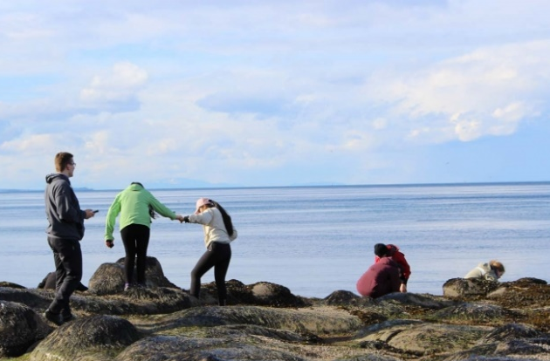
YouthToSea members can also use outreach hours earned through this program for community service and volunteer hours.

For members that are completing their Duke of Edinburgh International Award, the program will help them complete the Community Service, Skill Building, and Adventurous Journey portions of the award. Ocean Wise representatives will be able to sign off on any components completed through the program.

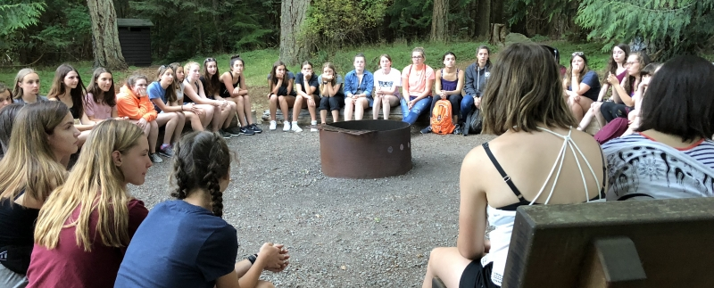

APPLICATION PROCESS
We are looking for youth (14-21) who are passionate about ocean protection and sustainability. YouthToSea is a great opportunity to protect our oceans, develop your leadership skills and be part of a great team of like-minded youth.

If you are interested in joining The YouthToSea program, please fill out our application form here:

https://docs.google.com/forms/d/1EgjvDqzYYCv49EEHYSlHBSg3LO716rV3-7hv59uR8H8/edit

Once you have filled out the form, a member of our team will be in contact to discuss your application. To be selected as a council member you must first complete 3 months in the YouthToSea program to demonstrate your commitment and ability to lead ocean conservation projects. Students who have a history of organizing ocean conservation events may be considered for a council position immediately.

If you are outside of this age range but interested in joining as a professional advisor, please contact us. We have opportunities for older youth to become mentors as well as volunteer opportunities for anyone looking to get involved.

If you have any questions about application or joining our program, please email yelp@ocean.org.

MEETINGS AND WORKSHOPS
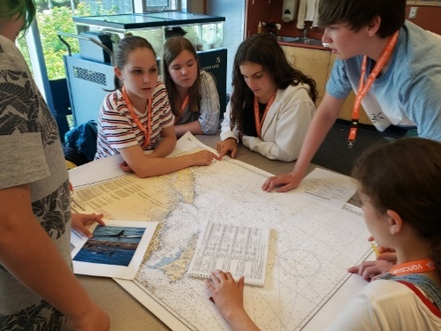
Monthly call in meetings will be organized by the council at a time that is convenient for our members.

Workshops will be hosted by the YouthToSea Council executive at the Vancouver Aquarium to facilitate ocean project development. These workshops will also be available online for our participants not in the Vancouver area.

October 26th, 2019 – Ignite the Spark, Inspiring and Empowering Youth to Take Action
December 2019 – Into Action, Moving from Ideas to Action
March 2020 – Shareable Stories, How to Share your Projects to Inspire Others

We will also provide members with access to an events calendar with YouthToSea outreach events and volunteer opportunities.

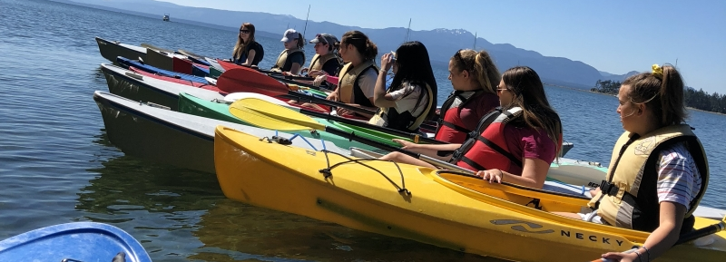

COMMUNITY CHALLENGES
Not sure where to get started? Check out our list of challenges you can run in your own community.

- Great Canadian Shoreline Cleanup – Get a group together and head out to do a cleanup. A shoreline cleanup can be done anywhere in the watershed, it does not necessarily have to be along the ocean shoreline. You can find good areas and signup at https://www.shorelinecleanup.ca/youth
- Host a documentary screening – Find an ocean themed documentary and screen it during lunch at your school. Have a discussion afterwards about ocean issues and what we can do to help.
- Plan a plastic free lunch week at school – Challenge your class or school to a plastic free week. For added challenge give everyone in your class a container where they put their plastic waste throughout the week. The winner of the week will have the least amount of plastic in their container.
- Commit to making a change at https://10000chages.ca/ and share it to encourage others
- Run a “Make your Own” workshop. Ideas include: natural cleaner, soap, beeswax wrapping, upcycling.
- Host a watershed walk. Get out in your community to lead a hike of your local watershed, highlighting the connection between the watershed and the ocean.

OCEAN WISE
In 2017, Ocean Wise was launched as a new global ocean conservation organization focused on protection and restoring our world’s oceans. Building on the roots of the Vancouver Aquarium Marine Science Centre, which started as a community-based not-for-profit organization, Ocean Wise aims to inspire people in every corner of the planet to participate in creating healthy oceans.

Our vision is a world in which oceans are healthy and flourishing. Our mission is to inspire the global community to become Ocean Wise by increasing its understanding, wonder and appreciation for our oceans.

